Image Sharpening Using High-Boost Masks
Experiment No: 24
Aim
To perform sharpening of an image using a High-Boost Mask in Python using the OpenCV library.
Theory
High-boost filtering is an image sharpening technique in which the original image is multiplied by a constant , and the blurred image is subtracted from it.
The high-boost filtering equation is:
where:
- = original image
- = blurred image
- = amplification factor
- = sharpened image
When A = 1, the filter becomes standard Laplacian sharpening.
The masks shown in your question are:
4-neighbor mask
8-neighbor mask
For this experiment, we can use the 8-neighbor high-boost mask
Tools Required
- Python 3.x
- OpenCV (cv2)
- NumPy
- VS Code / PyCharm / Jupyter Notebook
- Input image (image.jpg)
Procedure
- Install OpenCV and NumPy:
Bash
pip install opencv-python numpy
- Read the input image using OpenCV.
- Convert the image to grayscale.
- Select the high-boost amplification factor , where .
- Create the 8-neighbor high-boost mask.
- Apply the mask using cv2.filter2D().
- Display the original and sharpened images.
- Observe the enhancement of edges and fine details.
Code
import cv2
import numpy as np

# Read the image
image = cv2.imread("image.jpg")

# Check if image is loaded
if image is None:
print("Error: Image not found!")
exit()

# Convert image to grayscale
gray = cv2.cvtColor(image, cv2.COLOR_BGR2GRAY)

# High-boost amplification factor
A = 2

# 8-neighbor high-boost mask
mask = np.array([
[-1, -1, -1],
[-1, A + 8, -1],
[-1, -1, -1]
], dtype=np.float32)
# Apply high-boost mask
sharpened = cv2.filter2D(gray, -1, mask)
# Display original image
cv2.imshow("Original Image", gray)
# Display sharpened image
cv2.imshow("High-Boost Sharpened Image", sharpened)
# Wait for a key press
cv2.waitKey(0)

# Close all windows
cv2.destroyAllWindows()
Output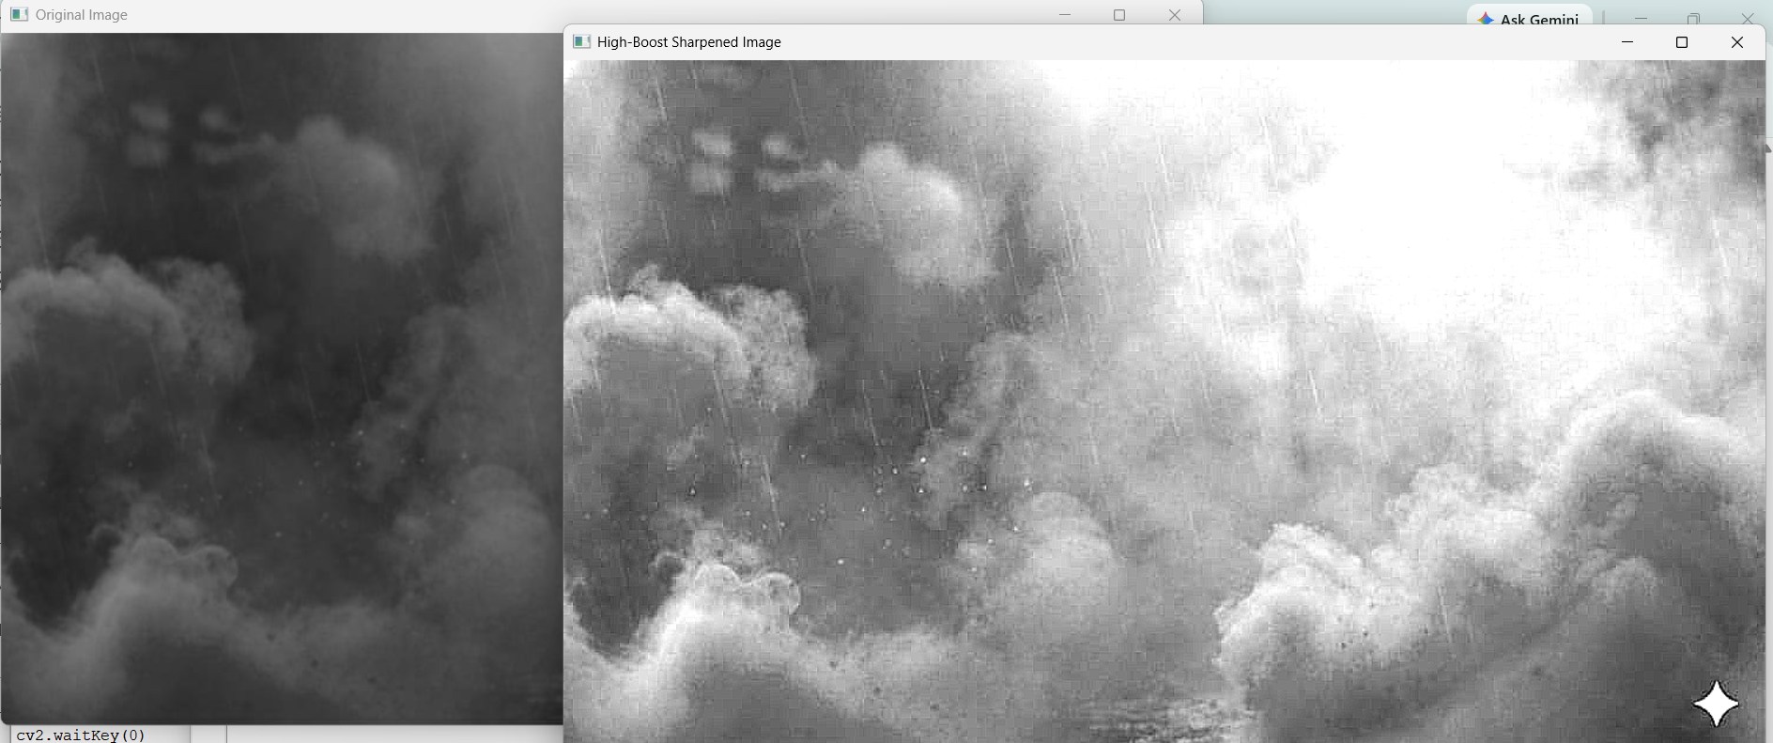
Result
The image was successfully sharpened using a High-Boost Mask. An amplification factor was used with the 8-neighbor high-boost mask, resulting in enhanced edges and finer image details.

